NAME: NAVODITAA A.R.
ROLL NO :241901071

Exercise 15

DEMONSTRATE NETWORK FORENSICS USING PCAPXRAY TOOLS
Introduction:
Network forensics involves capturing, analyzing, and investigating network traffic to detect malicious activities or anomalies. PcapXray is a tool that visualizes packet capture (PCAP) files, showing hosts, connections, web/Tor traffic, and potentially malicious activities in a network. It helps investigators quickly identify suspicious traffic flows and extract relevant payloads for deeper analysis.
Aim:
To analyze captured network traffic using PcapXray and identify hosts, traffic patterns, and suspicious network activities for forensic investigation.
Algorithm:
- Install prerequisites:
  - Install Python 3, pip, Graphviz, Tkinter, and required libraries.
  - Clone the PcapXray repository and install dependencies using pip install -r requirements.txt.
- Prepare input:
  - Obtain a .pcap file containing network traffic to be analyzed.
  - Ensure the PCAP is from a safe/testing source for learning purposes.
- Launch PcapXray:
  - Open main.py in the repository using Python.
  - Load the selected .pcap file via the GUI.
- Analyze traffic:
  - Observe the network graph of hosts (nodes) and connections (edges).
  - Filter traffic based on Web, Tor, Malicious, DNS, or ICMP.
  - Click on nodes/edges to view traffic details, HTTP requests, or extracted payloads.
- Record observations:
  - Note suspicious hosts, unusual ports, or Tor traffic.
  - Check extracted files or payloads for anomalies.
  - Optionally, cross-verify suspicious IPs with WHOIS or threat intelligence sources.
- Document results:
  - Capture screenshots of network diagrams and significant flows.
  - Summarize the suspicious activities identified during analysis.
Output:
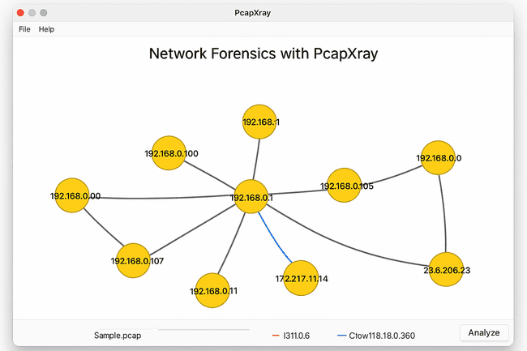
- Graphical visualization of network hosts and flows.
- Reports listing:
  - Host IPs
  - Connection types
  - Protocols used
  - Extracted payloads
  - Flags for Tor/malicious traffic
- Optional JSON or text files summarizing traffic analysis.
Result :
- Hosts with the most connections were identified as central nodes.
- Web traffic, Tor traffic, and DNS requests were visualized clearly.
- Suspicious or unusual traffic flows were highlighted for further investigation.
- Payload extraction revealed potential files or URLs of interest.
- PcapXray provided a clear, interactive overview of network activity, making it easier to identify anomalies or malicious patterns compared to raw packet inspection in Wireshark.

